**How to Use JMeter for Performance & Load Testing**

Performance[Testing](https://www.guru99.com/software-testing.html)is crucial to determine that the web application under test will satisfy **high load** requirements. It can be used to analyze overall server performance under heavy load.

[](https://www.guru99.com/images/PerformanceTesting.png)

Apache JMeter testing tool offers following **benefit** in [Performance Testing](https://www.guru99.com/performance-testing.html)

* JMeter can be used to test the performance of both **static** resources such as[JavaScript](https://www.guru99.com/interactive-javascript-tutorials.html)and HTML, as well as **dynamic** resources, such as JSP, Servlets, and AJAX.
* JMeter can **discover** maximum number of concurrent users that your website can handle
* JMeter provides a variety of graphical analyses of performance reports.

JMeter Performance Testing includes:

[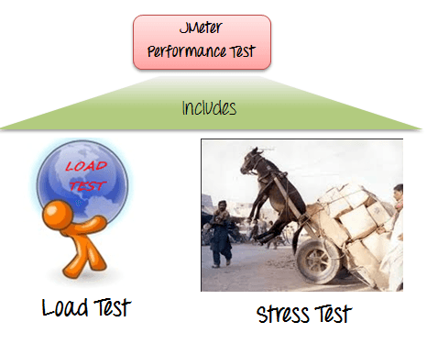](https://www.guru99.com/images/JMeterPerformanceTest.png)

* **Load**Testing: Modeling the expected usage by simulating multiple user access the[Web services](https://www.guru99.com/web-services-tutorial.html)concurrently.
* **Stress** Testing: Every web server has a maximum load capacity. When the load goes beyond the limit, the web server starts responding slowly and produce errors. The purpose of the [Stress Testing](https://www.guru99.com/stress-testing-tutorial.html) is to find the maximum load the web server can handle.

The figure below shows how JMeter load Testing simulates the heavy load:

[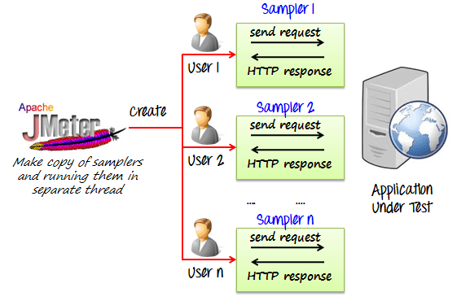](https://www.guru99.com/images/JMeterApacheSampler.png)

**Create a Performance Test Plan in JMeter**

In this tutorial, we are doing a performance analysis of Google.com for 1000 users

Before testing the performance of target web application, we should determine-

* **Normal Load**: Average number of users visit your website
* **Heavy Load**: The maximum number of users visit your website
* What is your **target** in this test?

Here is the **roadmap** of this practical example

[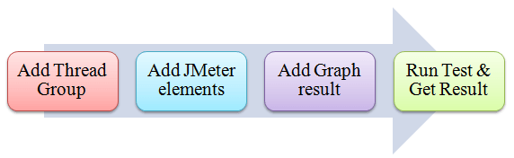](https://www.guru99.com/images/JMeterTestPlanFlow.png)

**Step 1) Add Thread Group**

1. Start **JMeter**
2. Select **Test Plan** on the tree
3. Add **Thread Group**

Right click on the "Test Plan" and add a new thread group: **Add**-> **Threads (Users)** -> **Thread Group**

[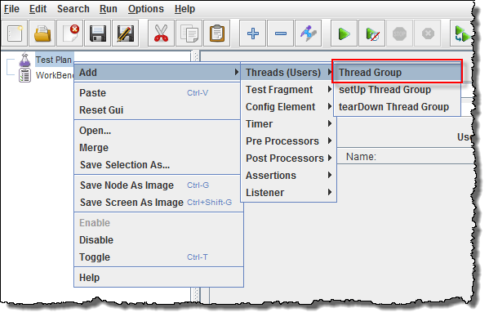](https://www.guru99.com/images/JMeterAddThreadGroup.png)

In the Thread Group control panel, enter Thread Properties as follows:

[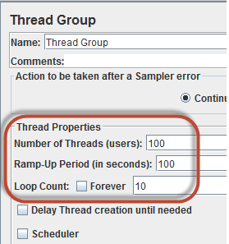](https://www.guru99.com/images/ThreadGroupJMeterPerformance.png)

* **Number of Threads**: 100 (Number of users connects to the target website: 100)
* **Loop Count**: 10 (Number of time to execute testing)
* **Ramp-Up Period**: 100

The Thread Count and The Loop Counts are **different.**

[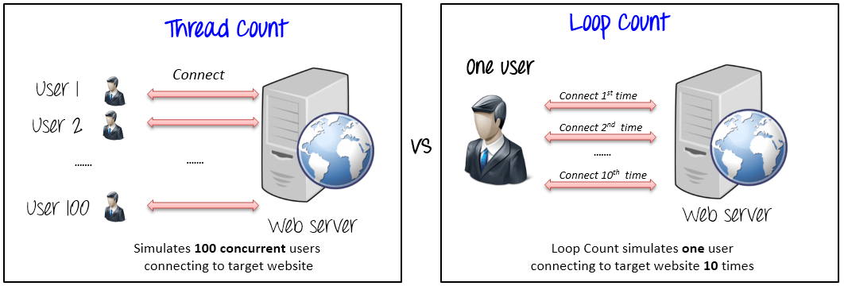](https://www.guru99.com/images/ThreadCountVSLoopCount.png)

Ramp-Up Period tells JMeter how long to **delay** before starting the next user. For example, if we have 100 users and a 100-second Ramp-Up period, then the delay between starting users would be 1 second (100 seconds /100 users)

**[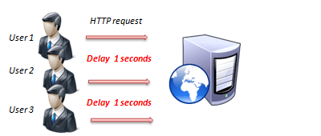](https://www.guru99.com/images/UserDelayHTTP.png)**

**Step 2) Adding JMeter elements**

Now we determine what JMeter elements in this test. The elements are

* **HTTP request Default**

This element can be added by right-clicking on the Thread Group and selecting: **Add**->**Config Element**->**HTTP Request Defaults.**

[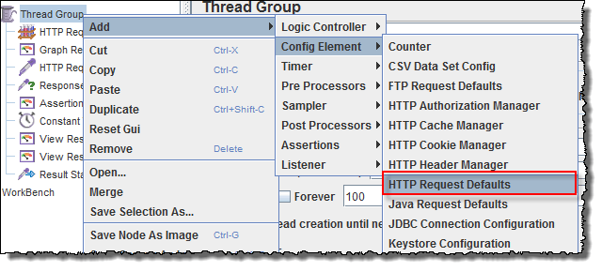](https://www.guru99.com/images/ThreadGroupAddJMeterPerformance.png)

In the HTTP Request Defaults control panel, enter the Website name under test ([http://www.google.com](http://www.google.com/))

[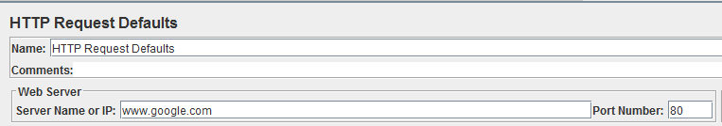](https://www.guru99.com/images/HTTPRequestJMeterPerformance.png)

* **HTTP Request**

Right-click on Thread Group and select: **Add**->**Sampler**->**HTTP Request**.

[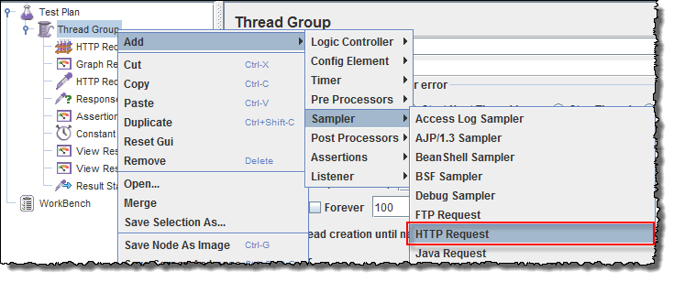](https://www.guru99.com/images/AddHTTPRequestJmeterPerformance.png)

In HTTP Request Control Panel, the Path field indicates which **URL request** you want to send to Google server.

[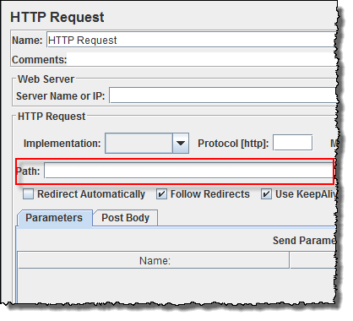](https://www.guru99.com/images/HTTPRequestControlPanelJMeter.png)

For example, if you enter "*calendar*" in Path field. JMeter will create the URL request <http://www.google.com/calendar>  to Google server

[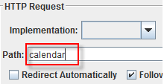](https://www.guru99.com/images/HTTPRequestCalenderJMeter.png)

If you keep the Path field blank  JMeter will create the URL request [http://www.google.com](http://www.google.com/) to Google server.

**In this test, you keep the Path field blank to make JMeter create the URL request**[**http://www.google.com**](http://www.google.com/)**to Google server.**

**Step 3) Adding Graph result**

JMeter can show the test result in Graph format.

Right click Test Plan, **Add**->**Listener**->**Graph Results**

[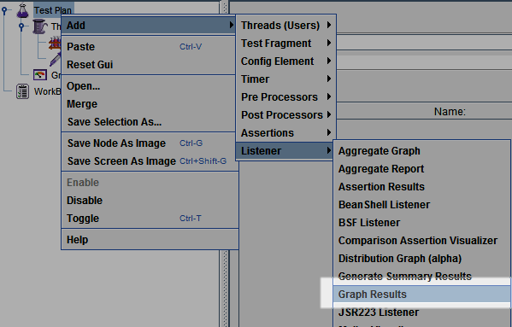](https://www.guru99.com/images/AddGrapgResultJMeter.png)

**Step 4) Run Test and get the test result**

Press **the Run** button (Ctrl + R) on the Toolbar to start the software testing process. You will see the test result display on Graph in the real time.

The picture below presents a graph of a test plan, where we simulated 100 users who accessed on website [www.google.com](http://www.google.com/).

[](https://www.guru99.com/images/RunTestPlan.gif)

At the bottom of the picture, there are the following statistics, represented in colors:

* Black: The total number of current samples sent.
* Blue: The current average of all samples sent.
* Red: The current standard deviation.
* Green: Throughput rate that represents the number of requests per minute the server handled

Let analyze the performance of Google server in below figure.

[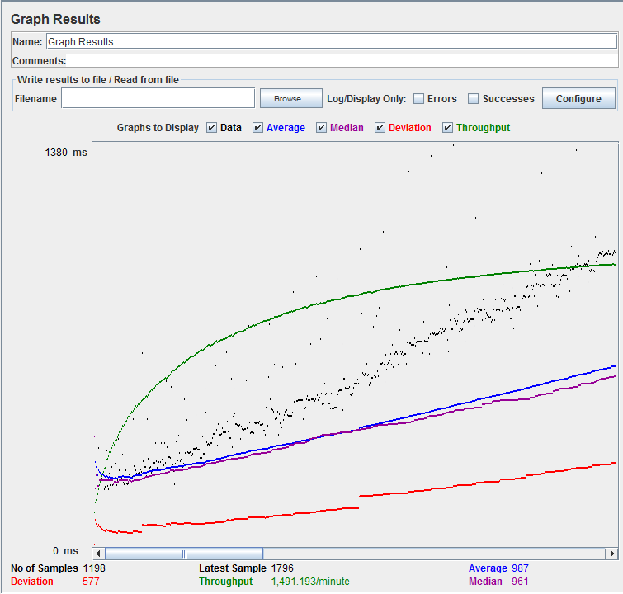](https://www.guru99.com/images/GraphResultGraphJMeter.png)

To analyze the performance of the web server under test, you should focus on 2 parameters

* Throughput
* Deviation

The **Throughput** is the most important parameter. It represents the ability of the server to handle a heavy load.  The **higher** the Throughput is, the **better** is the server performance.

In this test, the throughput of Google server is 1,491.193/minute. It means Google server can handle 1,491.193 requests per minute. This value is quite high so we can conclude that Google server has good performance

The **deviation** is shown in red - it indicates the deviation from the average. The **smaller** the **better**.

Let compare the performance of Google server to other web servers. This is the performance test result of website <http://www.yahoo.com/> (You can choose other websites)

[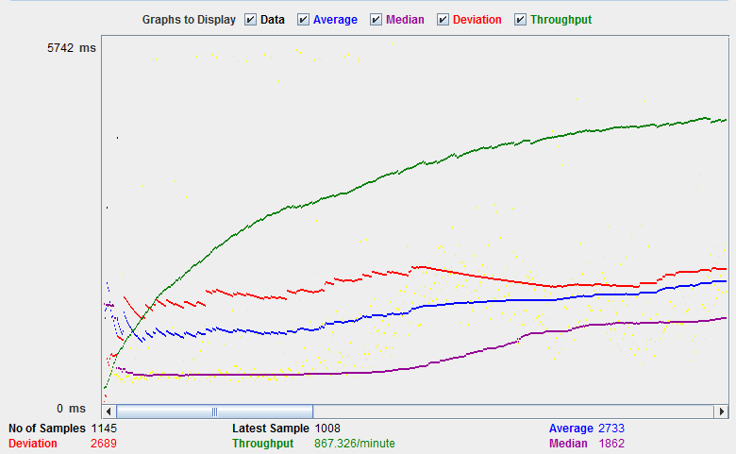](https://www.guru99.com/images/GraphToDisplayJMeter.png)

The throughput of a website under test [http://www.yahoo.com](http://www.yahoo.com/) is 867.326/minutes. It means this server handle 867.326 requests per minute, lower than Google.

The deviation is 2689, much higher than Google (577). So we can determine the performance of this website is less than a Google server.